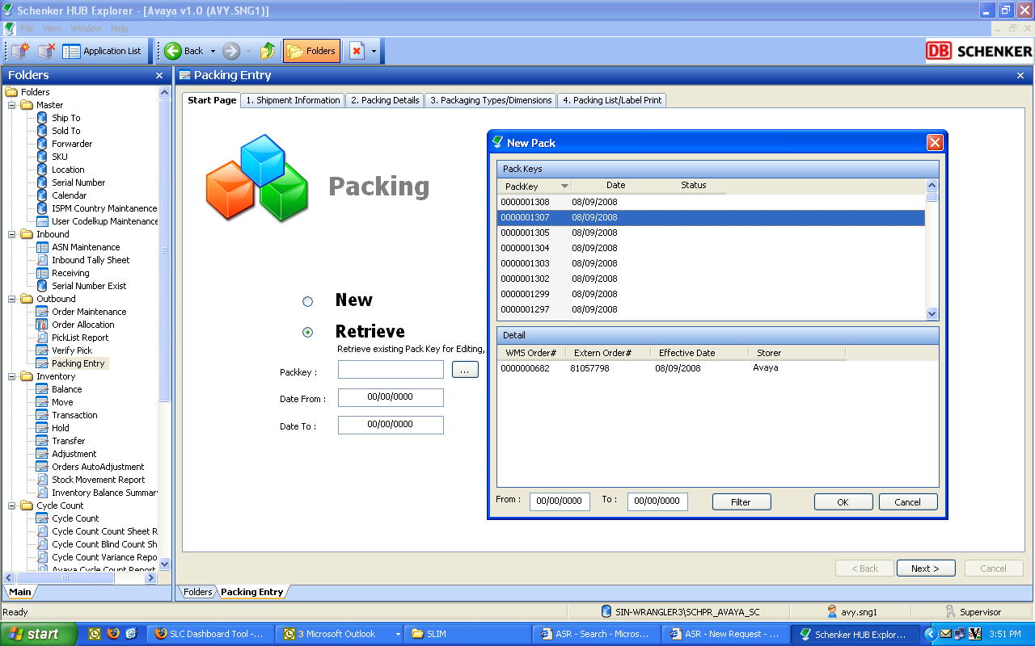

When we do a retrieve, we would like you to add in the WMS# and DN#

